Responsible teacher: Barbara Gallina, tel. 021-101631.

**NAME:**

**SURNAME:**

**PERSONAL NUMBER:**

**SIGNATURE:**

**This is an “open book” exam.**

**Be careful, an “open book” exam does not mean that you are allowed to cooperate or copy material from other sources.**

**Do not forget that cheating is disciplined with a warning or suspension. For more information, check:**

[**https://www.mdh.se/en/malardalen-university/student/study-guide/deception-and-disturbance**](https://www.mdh.se/en/malardalen-university/student/study-guide/deception-and-disturbance)

**You are expected to provide your answers in this document (by editing it) and then generate a pdf and send it back to:** [**barbara.gallina@mdh.se**](mailto:barbara.gallina@mdh.se)

**Ideally, I should receive one single pdf.**

**If for some reasons you want to use other separate sheets and use your hand-writing, make sure that your writing/answers is/are readable, take a picture and insert the picture into the document, alternatively, you are allowed to send separate sheets/files if you cannot merge easily the separate files into a single pdf. However, all of the additional files have to include your name, surname, personal number, signature. Your e-mail must clearly state the number of submitted files.**

Max points: 30

**Approved: Minimum 15 points**

**Grade 5:** 27 – 30 p **Grade A:** 28 – 30 p

**Grade 4:** 21 – 26.9 p **Grade B:** 25 – 27.9 p

**Grade 3:** 15 – 20.9 p **Grade C:** 22 – 24.9 p

**Grade D:** 18 – 21.9 p

**Grade E:** 15 – 17.9 p

Assumptions must be made when there is not enough information provided to solve an assignment, and all assumptions must be specified and explained in order to achieve full points.

**Good luck!**

### 1. Terminological framework related to dependability (10p)

# “Software fix coming for Metro rail car doors that close without warning message”

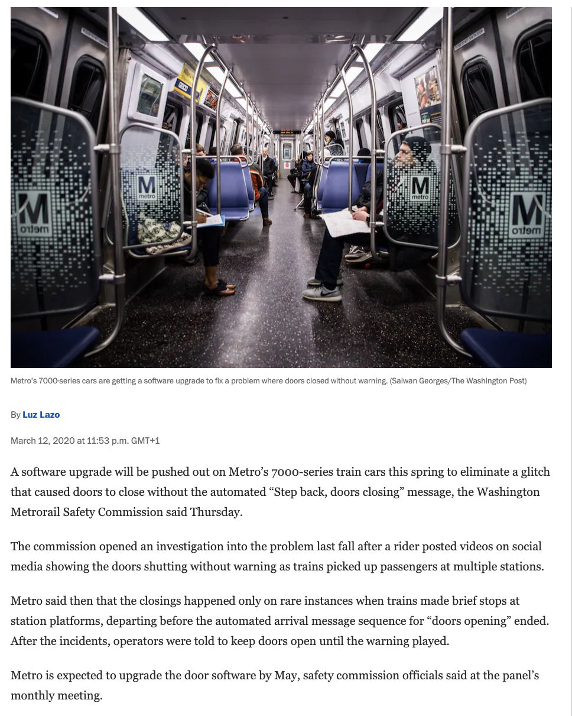

“…the safety commission’s chief operating officer, said that while problems with the closing doors is infrequent, it is a major safety concern for some riders. The recorded warning is critical to alert passengers entering and exiting the trains, especially those who are visually impaired. It is also a federal requirement listed in the Americans With Disabilities Act.

“A passenger could be injured or trapped between doors,” she said.

Metro at the time said rail car engineers and technicians conducted an inspection of all 7000-series cars and found no other glitches. But they found that the rail cars’ audible messaging system can play only one informational message at a time. The software upgrade will fix that.”

Assume that the above-given pieces of news provide faithful information. Make use of the terminological framework related to dependability and to the etiology of accidents to describe:

1. what happened (highlight threats, by clarifying the threatened dependability attribute(s), and any eventual causation relationship.

Reminder: do not forget to consider the **preliminary concepts** related to dependability. Add **your own assumptions** whenever appropriate and do not forget to **properly identify and classify the threats**) (5p)

**Answer:**

### (This page intentionally left blank. Space can be used for question 1)

b) Discuss potential counter-measures, which could have been considered to handle the case described in the pieces of news. Note: you are expected to show your knowledge/skills w.r.t. counter-measures classification by **motivating your selection in relation to the scenarios identified in answer a)**. (5p)

**Answer:**

### (This page intentionally left blank. Space can be used for question 1)

### 2. FMECA (5p)

In the urban rail systems, automatic train operation (ATO) refers to a system which performs all or part of the responsibilities assigned to the driver. Similar to the road vehicles, the share of tasks between the driver and the system is defined by several GoA (Grades of Automation). In this case, we consider that the driver has no tasks (UTO -Unattended Train Operation).

Consider the high-level system depicted in Figure 1.

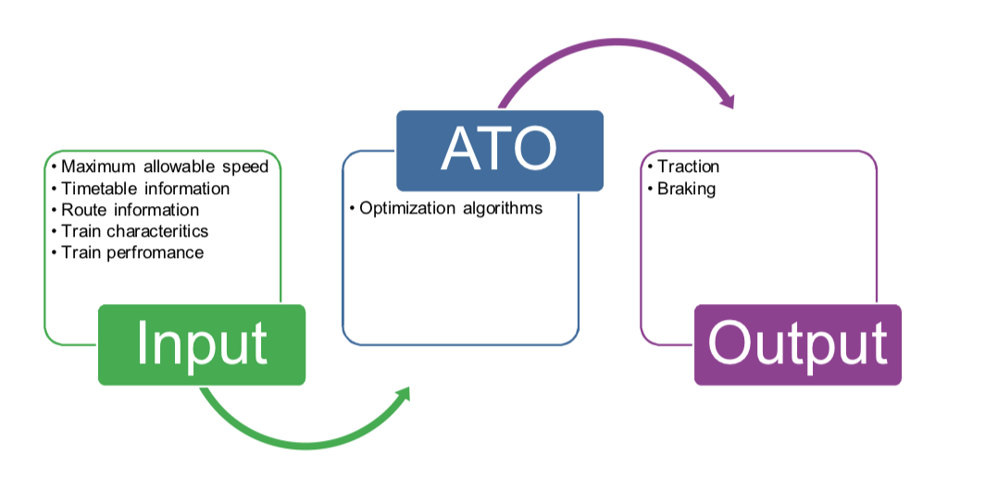

Figure 1 -ATO system

Consider that for instance Timetable information includes arrival times, departure times, dwell times, platform stopping locations and disruptions. This information is communicated from the trackside ATO to the on-board ATO. The on-board ATO uses this information to calculate the speed profile that meets the timetable requirements.

Consider that the train is expected to stop with precision especially in stations equipped with Platform Screen Doors (see Figure 2 for visualizing Platform Screen Doors and possible related scenarios).

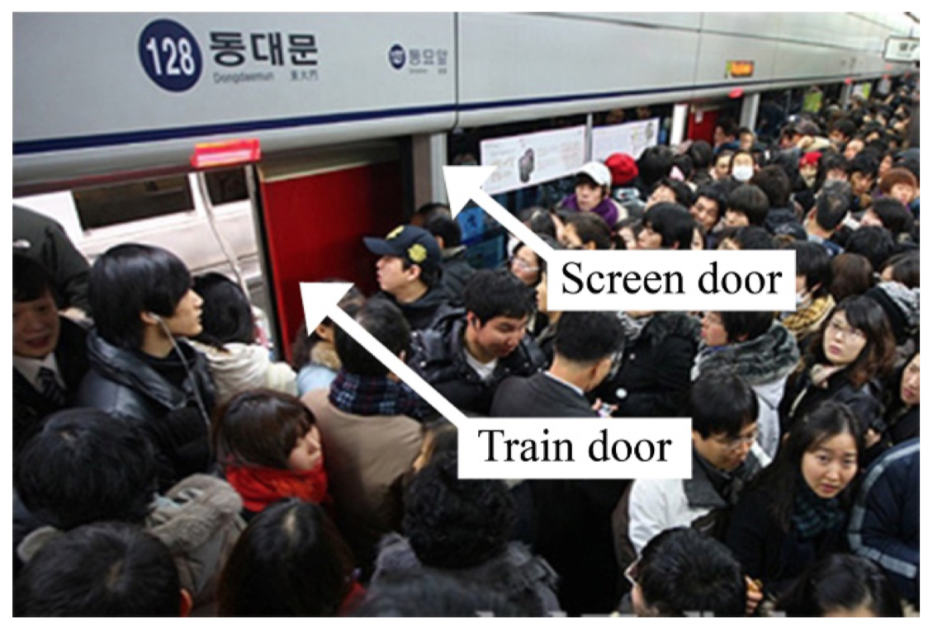

Figure 2 Platform Screen Doors-related scenario-example.

Note that precision stopping of an urban train at a railway station with platform screen doors is essential to passenger safety and timely revenue service. Consider this specification “tolerance range for the precision stopping of urban trains is ±30 cm”.

Use FMECA and provide your analysis reasoning about what could go wrong.

**Answer:**

### (This page intentionally left blank. Space can be used for question 2)

### (This page intentionally left blank. Space can be used for question 2)

### 3 Argumentation (15)

a) By following the recommendations provided by The Public Health Agency of Sweden, summarized in Figure 3, each person can be part of the solution and help reducing the spread of COVID-19 infection.

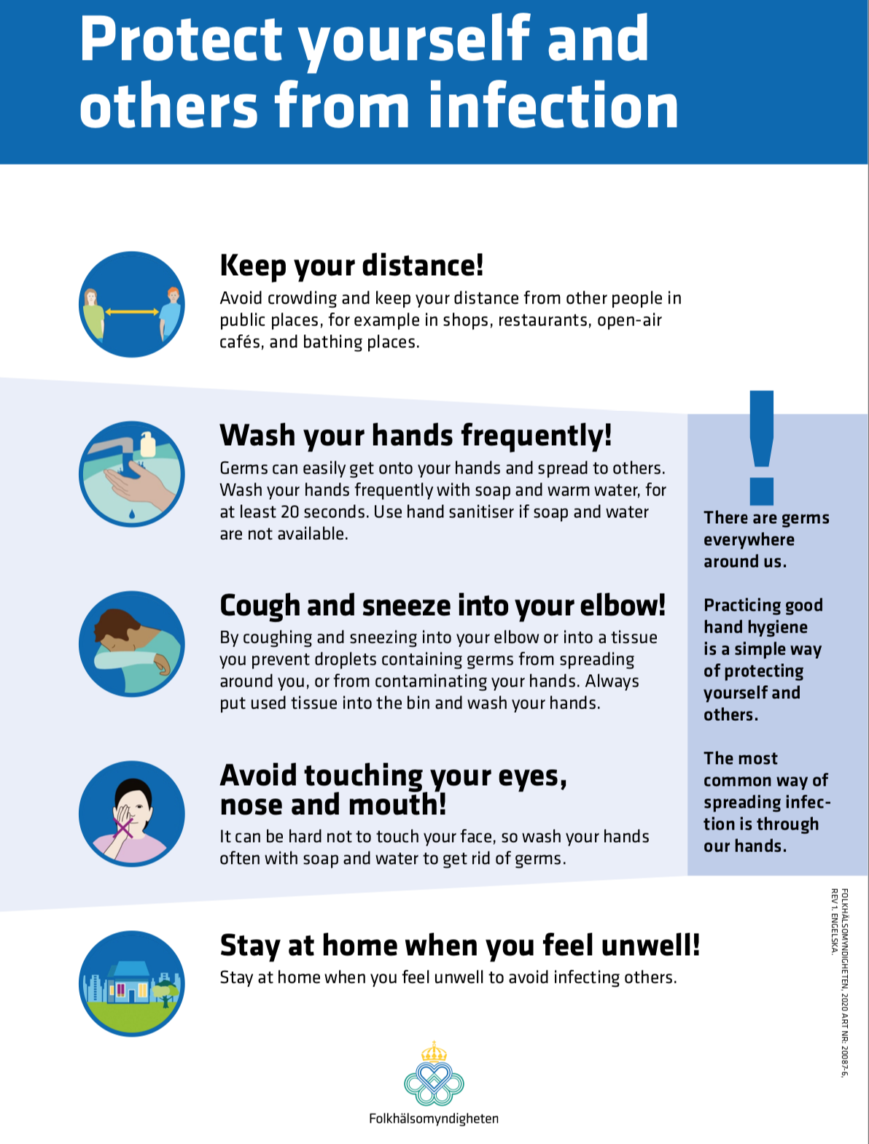

Figure 3

a) Use GSN and argue about:

-“I am acting as part of the solution.” XOR

-“I am not acting as part of the solution.”

(4p)

**Answer:**

### (This page intentionally left blank. Space can be used for question 3.)

**b)** Then, use CAE and argue about the same claim chosen in 3.a):

(4p)

**Answer:**

c) Provide your own reflection about GSN vs. CAE based on your findings in 3.a) and 3.b)

(2p)

d) As you know, while arguing, one may introduce fallacies. Consider your GSN-argument, provided in question 3.a), choose at least 2 fallacies, and discuss about their presence or absence in your argument. (5p)

**Answer:**

(This page intentionally left blank. Space can be used for question 3.)

(This page intentionally left blank. Space can be used for question 3.)